Transaction

* The transaction is a set of logically related operation. It contains a group of tasks.
* A transaction is an action or series of actions. It is performed by a single user to perform operations for accessing the contents of the database.

Each high level operation can be divided into a number of low level tasks or operations. For example, a data update operation can be divided into three tasks −

* **read_item()** − reads data item from storage to main memory.
* **modify_item()** − change value of item in the main memory.
* **write_item()** − write the modified value from main memory to storage.

Database access is restricted to read_item() and write_item() operations. Likewise, for all transactions, read and write forms the basic database operations.

Transaction Operations

The low level operations performed in a transaction are −

* **begin_transaction** − A marker that specifies start of transaction execution.
* **read_item or write_item** − Database operations that may be interleaved with main memory operations as a part of transaction.
* **end_transaction** − A marker that specifies end of transaction.
* **commit** − A signal to specify that the transaction has been successfully completed in its entirety and will not be undone.
* **rollback** − A signal to specify that the transaction has been unsuccessful and so all temporary changes in the database are undone. A committed transaction cannot be rolled back.

## Transaction States

A transaction may go through a subset of five states, active, partially committed, committed, failed and aborted.

* **Active** − The initial state where the transaction enters is the active state. The transaction remains in this state while it is executing read, write or other operations.
* **Partially Committed** − The transaction enters this state after the last statement of the transaction has been executed.
* **Committed** − The transaction enters this state after successful completion of the transaction and system checks have issued commit signal.
* **Failed** − The transaction goes from partially committed state or active state to failed state when it is discovered that normal execution can no longer proceed or system checks fail.
* **Aborted** − This is the state after the transaction has been rolled back after failure and the database has been restored to its state that was before the transaction began.

The following state transition diagram depicts the states in the transaction and the low level transaction operations that causes change in states.

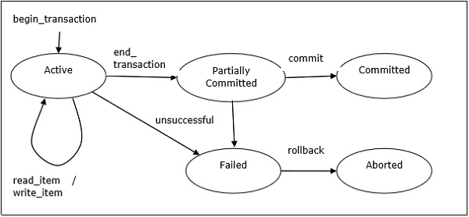

Desirable Properties of Transactions

Any transaction must maintain the ACID properties, viz. Atomicity, Consistency, Isolation, and Durability.

# **ACID Properties in DBMS**

DBMS is the management of data that should remain integrated when any changes are done in it. It is because if the integrity of the data is affected, whole data will get disturbed and corrupted. Therefore, to maintain the integrity of the data, there are four properties described in the database management system, which are known as the **ACID** properties. The ACID properties are meant for the transaction that goes through a different group of tasks, and there we come to see the role of the ACID properties.

In this section, we will learn and understand about the ACID properties. We will learn what these properties stand for and what does each property is used for. We will also understand the ACID properties with the help of some examples.

## ACID Properties

The expansion of the term ACID defines for:

* 1. **Atomicity:** The term atomicity defines that the data remains atomic. It means if any operation is performed on the data, either it should be performed or executed completely or should not be executed at all. It further means that the operation should not break in between or execute partially. In the case of executing operations on the transaction, the operation should be completely executed and not partially.

**Example:** If Remo has account A having $30 in his account from which he wishes to send $10 to Sheero's account, which is B. In account B, a sum of $ 100 is already present. When $10 will be transferred to account B, the sum will become $110. Now, there will be two operations that will take place. One is the amount of $10 that Remo wants to transfer will be debited from his account A, and the same amount will get credited to account B, i.e., into Sheero's account. Now, what happens - the first operation of debit executes successfully, but the credit operation, however, fails. Thus, in Remo's account A, the value becomes $20, and to that of Sheero's account, it remains $100 as it was previously present.

In the above diagram, it can be seen that after crediting $10, the amount is still $100 in account B. So, it is not an atomic transaction.

The below image shows that both debit and credit operations are done successfully. Thus the transaction is atomic.

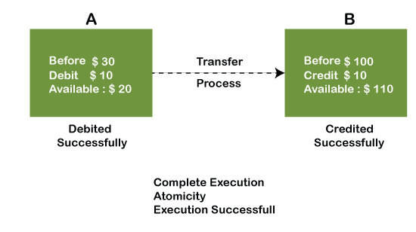

Thus, when the amount loses atomicity, then in the bank systems, this becomes a huge issue, and so the atomicity is the main focus in the bank systems.

**2) Consistency:** The word **consistency** means that the value should remain preserved always. In [DBMS](https://www.javatpoint.com/dbms-tutorial), the integrity of the data should be maintained, which means if a change in the database is made, it should remain preserved always. In the case of transactions, the integrity of the data is very essential so that the database remains consistent before and after the transaction. The data should always be correct.

**Example:**

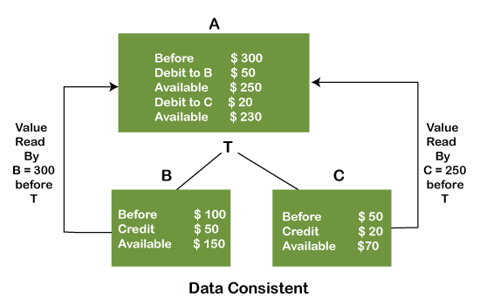

In the above figure, there are three accounts, A, B, and C, where A is making a transaction T one by one to both B & C. There are two operations that take place, i.e., Debit and Credit. Account A firstly debits $50 to account B, and the amount in account A is read $300 by B before the transaction. After the successful transaction T, the available amount in B becomes $150. Now, A debits $20 to account C, and that time, the value read by C is $250 (that is correct as a debit of $50 has been successfully done to B). The debit and credit operation from account A to C has been done successfully. We can see that the transaction is done successfully, and the value is also read correctly. Thus, the data is consistent. In case the value read by B and C is $300, which means that data is inconsistent because when the debit operation executes, it will not be consistent.

**4) Isolation:** The term 'isolation' means separation. In DBMS, Isolation is the property of a database where no data should affect the other one and may occur concurrently. In short, the operation on one database should begin when the operation on the first database gets complete. It means if two operations are being performed on two different databases, they may not affect the value of one another. In the case of transactions, when two or more transactions occur simultaneously, the consistency should remain maintained. Any changes that occur in any particular transaction will not be seen by other transactions until the change is not committed in the memory.

**Example:** If two operations are concurrently running on two different accounts, then the value of both accounts should not get affected. The value should remain persistent. As you can see in the below diagram, account A is making T1 and T2 transactions to account B and C, but both are executing independently without affecting each other. It is known as Isolation.

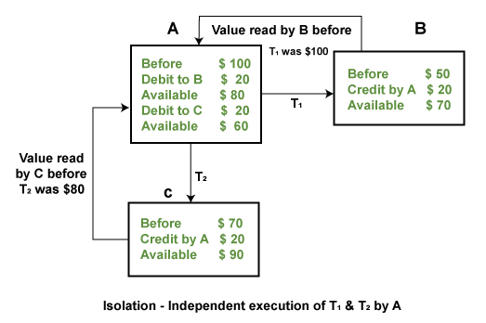

**4) Durability:** Durability ensures the permanency of something. In DBMS, the term durability ensures that the data after the successful execution of the operation becomes permanent in the database. The durability of the data should be so perfect that even if the system fails or leads to a crash, the database still survives. However, if gets lost, it becomes the responsibility of the recovery manager for ensuring the durability of the database. For committing the values, the COMMIT command must be used every time we make changes.

## Schedules and Conflicts

In a system with a number of simultaneous transactions, a **schedule** is the total order of execution of operations. Given a schedule S comprising of n transactions, say T1, T2, T3………..Tn; for any transaction Ti, the operations in Ti must execute as laid down in the schedule S.

### **Types of Schedules**

There are two types of schedules −

* **Serial Schedules** − In a serial schedule, at any point of time, only one transaction is active, i.e. there is no overlapping of transactions. This is depicted in the following graph −
* 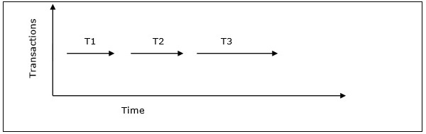

### **Conflicts in Schedules**

In a schedule comprising of multiple transactions, a **conflict** occurs when two active transactions perform non-compatible operations. Two operations are said to be in conflict, when all of the following three conditions exists simultaneously −

* The two operations are parts of different transactions.
* Both the operations access the same data item.
* At least one of the operations is a write_item() operation, i.e. it tries to modify the data item.

## Serializability

A **serializable schedule** of ‘n’ transactions is a parallel schedule which is equivalent to a serial schedule comprising of the same ‘n’ transactions. A serializable schedule contains the correctness of serial schedule while ascertaining better CPU utilization of parallel schedule.

# **View Serializability**

* A schedule will view serializable if it is view equivalent to a serial schedule.
* If a schedule is conflict serializable, then it will be view serializable.
* The view serializable which does not conflict serializable contains blind writes.

## View Equivalent

Two schedules S1 and S2 are said to be view equivalent if they satisfy the following conditions:

### **1. Initial Read**

An initial read of both schedules must be the same. Suppose two schedule S1 and S2. In schedule S1, if a transaction T1 is reading the data item A, then in S2, transaction T1 should also read A.

Above two schedules are view equivalent because Initial read operation in S1 is done by T1 and in S2 it is also done by T1.

### **2. Updated Read**

In schedule S1, if Ti is reading A which is updated by Tj then in S2 also, Ti should read A which is updated by Tj.

Above two schedules are not view equal because, in S1, T3 is reading A updated by T2 and in S2, T3 is reading A updated by T1.

### **3. Final Write**

A final write must be the same between both the schedules. In schedule S1, if a transaction T1 updates A at last then in S2, final writes operations should also be done by T1.

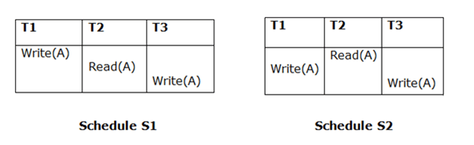

Above two schedules is view equal because Final write operation in S1 is done by T3 and in S2, the final write operation is also done by T3.

**Example:**

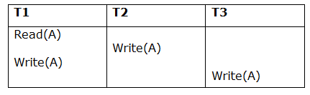

**Schedule S**

With 3 transactions, the total number of possible schedule

1. = 3! = 6
2. S1 = <T1 T2 T3>
3. S2 = <T1 T3 T2>
4. S3 = <T2 T3 T1>
5. S4 = <T2 T1 T3>
6. S5 = <T3 T1 T2>
7. S6 = <T3 T2 T1>

**Taking first schedule S1:**

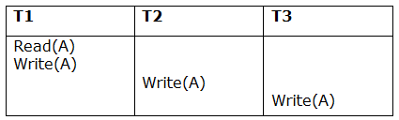

**Schedule S1**

**Step 1:** final updation on data items

In both schedules S and S1, there is no read except the initial read that's why we don't need to check that condition.

**Step 2:** Initial Read

The initial read operation in S is done by T1 and in S1, it is also done by T1.

**Step 3:** Final Write

# **Conflict Serializable Schedule**

* A schedule is called conflict serializability if after swapping of non-conflicting operations, it can transform into a serial schedule.
* The schedule will be a conflict serializable if it is conflict equivalent to a serial schedule.

## Conflicting Operations

The two operations become conflicting if all conditions satisfy:

1. Both belong to separate transactions.
2. They have the same data item.
3. They contain at least one write operation.

### **Example:**

Swapping is possible only if S1 and S2 are logically equal.

Here, S1 = S2. That means it is non-conflict.

Here, S1 ≠ S2. That means it is conflict.

## Conflict Equivalent

In the conflict equivalent, one can be transformed to another by swapping non-conflicting operations. In the given example, S2 is conflict equivalent to S1 (S1 can be converted to S2 by swapping non-conflicting operations).

Two schedules are said to be conflict equivalent if and only if:

1. They contain the same set of the transaction.
2. If each pair of conflict operations are ordered in the same way.

### **Example:**

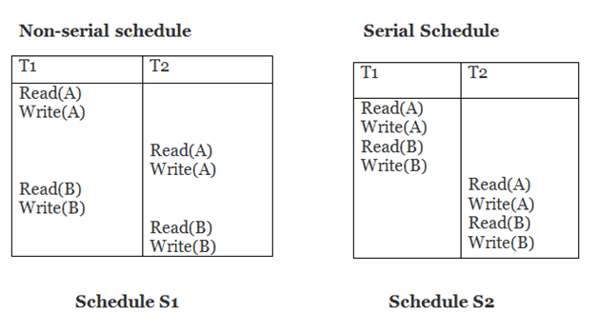

Schedule S2 is a serial schedule because, in this, all operations of T1 are performed before starting any operation of T2. Schedule S1 can be transformed into a serial schedule by swapping non-conflicting operations of S1.

**After swapping of non-conflict operations, the schedule S1 becomes:**

|  |  |
| --- | --- |
| **T1** | **T2** |
| Read(A) Write(A) Read(B) Write(B) | Read(A) Write(A) Read(B) Write(B) |

Since, S1 is conflict serializable.

Recoverability of Schedule

Sometimes a transaction may not execute completely due to a software issue, system crash or hardware failure. In that case, the failed transaction has to be rollback. But some other transaction may also have used value produced by the failed transaction. So we also have to rollback those transactions.

The above table 1 shows a schedule which has two transactions. T1 reads and writes the value of A and that value is read and written by T2. T2 commits but later on, T1 fails. Due to the failure, we have to rollback T1. T2 should also be rollback because it reads the value written by T1, but T2 can't be rollback because it already committed. So this type of schedule is known as irrecoverable schedule.

**Irrecoverable schedule:** The schedule will be irrecoverable if Tj reads the updated value of Ti and Tj committed before Ti commit.

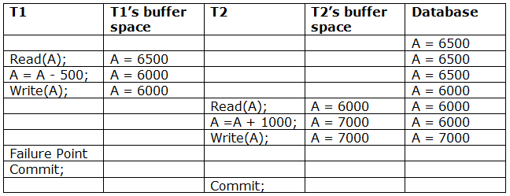

The above table 2 shows a schedule with two transactions. Transaction T1 reads and writes A, and that value is read and written by transaction T2. But later on, T1 fails. Due to this, we have to rollback T1. T2 should be rollback because T2 has read the value written by T1. As it has not committed before T1 commits so we can rollback transaction T2 as well. So it is recoverable with cascade rollback.

**Recoverable with cascading rollback:** The schedule will be recoverable with cascading rollback if Tj reads the updated value of Ti. Commit of Tj is delayed till commit of Ti.

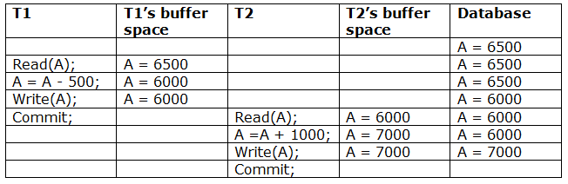

The above Table 3 shows a schedule with two transactions. Transaction T1 reads and write A and commits, and that value is read and written by T2. So this is a cascade less recoverable schedule.

**Log based Recovery in DBMS**

# **Log-Based Recovery**

* The log is a sequence of records. Log of each transaction is maintained in some stable storage so that if any failure occurs, then it can be recovered from there.
* If any operation is performed on the database, then it will be recorded in the log.
* But the process of storing the logs should be done before the actual transaction is applied in the database.

Let's assume there is a transaction to modify the City of a student. The following logs are written for this transaction.

* When the transaction is initiated, then it writes 'start' log.
  1. <Tn, Start>
* When the transaction modifies the City from 'Noida' to 'Bangalore', then another log is written to the file.
  1. <Tn, City, 'Noida', 'Bangalore' >
* When the transaction is finished, then it writes another log to indicate the end of the transaction.
  1. <Tn, Commit>

There are two approaches to modify the database:

### **1. Deferred database modification:**

* The deferred modification technique occurs if the transaction does not modify the database until it has committed.
* In this method, all the logs are created and stored in the stable storage, and the database is updated when a transaction commits.

### **2. Immediate database modification:**

* The Immediate modification technique occurs if database modification occurs while the transaction is still active.
* In this technique, the database is modified immediately after every operation. It follows an actual database modification.

## Recovery using Log records

When the system is crashed, then the system consults the log to find which transactions need to be undone and which need to be redone.

1. If the log contains the record <Ti, Start> and <Ti, Commit> or <Ti, Commit>, then the Transaction Ti needs to be redone.
2. If log contains record<Tn, Start> but does not contain the record either <Ti, commit> or <Ti, abort>, then the Transaction Ti needs to be undone.

# **Checkpoint**

* The checkpoint is a type of mechanism where all the previous logs are removed from the system and permanently stored in the storage disk.
* The checkpoint is like a bookmark. While the execution of the transaction, such checkpoints are marked, and the transaction is executed then using the steps of the transaction, the log files will be created.
* When it reaches to the checkpoint, then the transaction will be updated into the database, and till that point, the entire log file will be removed from the file. Then the log file is updated with the new step of transaction till next checkpoint and so on.

## Recovery using Checkpoint

In the following manner, a recovery system recovers the database from this failure:

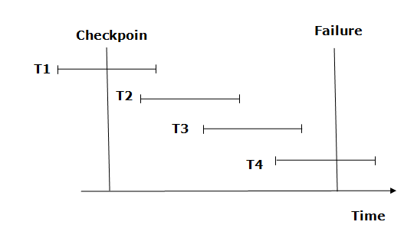

* The recovery system reads log files from the end to start. It reads log files from T4 to T1.
* Recovery system maintains two lists, a redo-list, and an undo-list.
* The transaction is put into redo state if the recovery system sees a log with <Tn, Start> and <Tn, Commit> or just <Tn, Commit>. In the redo-list and their previous list, all the transactions are removed and then redone before saving their logs.
* **For example:** In the log file, transaction T2 and T3 will have <Tn, Start> and <Tn, Commit>. The T1 transaction will have only <Tn, commit> in the log file. That's why the transaction is committed after the checkpoint is crossed. Hence it puts T1, T2 and T3 transaction into redo list.
* The transaction is put into undo state if the recovery system sees a log with <Tn, Start> but no commit or abort log found. In the undo-list, all the transactions are undone, and their logs are removed.
* **For example:** Transaction T4 will have <Tn, Start>. So T4 will be put into undo list since this transaction is not yet complete and failed amid.

# **Deadlock in DBMS**

A deadlock is a condition where two or more transactions are waiting indefinitely for one another to give up locks. Deadlock is said to be one of the most feared complications in DBMS as no task ever gets finished and is in waiting state forever.

**For example:** In the student table, transaction T1 holds a lock on some rows and needs to update some rows in the grade table. Simultaneously, transaction T2 holds locks on some rows in the grade table and needs to update the rows in the Student table held by Transaction T1.

Now, the main problem arises. Now Transaction T1 is waiting for T2 to release its lock and similarly, transaction T2 is waiting for T1 to release its lock. All activities come to a halt state and remain at a standstill. It will remain in a standstill until the DBMS detects the deadlock and aborts one of the transactions.

## Deadlock Avoidance

* When a database is stuck in a deadlock state, then it is better to avoid the database rather than aborting or restating the database. This is a waste of time and resource.
* Deadlock avoidance mechanism is used to detect any deadlock situation in advance. A method like "wait for graph" is used for detecting the deadlock situation but this method is suitable only for the smaller database. For the larger database, deadlock prevention method can be used.

## Deadlock Detection

In a database, when a transaction waits indefinitely to obtain a lock, then the DBMS should detect whether the transaction is involved in a deadlock or not. The lock manager maintains a Wait for the graph to detect the deadlock cycle in the database.

### **Wait for Graph**

* This is the suitable method for deadlock detection. In this method, a graph is created based on the transaction and their lock. If the created graph has a cycle or closed loop, then there is a deadlock.
* The wait for the graph is maintained by the system for every transaction which is waiting for some data held by the others. The system keeps checking the graph if there is any cycle in the graph.

The wait for a graph for the above scenario is shown below:

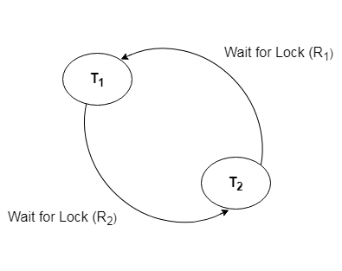

## Deadlock Prevention

* Deadlock prevention method is suitable for a large database. If the resources are allocated in such a way that deadlock never occurs, then the deadlock can be prevented.
* The Database management system analyzes the operations of the transaction whether they can create a deadlock situation or not. If they do, then the DBMS never allowed that transaction to be executed.

### **Wait-Die scheme**

In this scheme, if a transaction requests for a resource which is already held with a conflicting lock by another transaction then the DBMS simply checks the timestamp of both transactions. It allows the older transaction to wait until the resource is available for execution.

Let's assume there are two transactions Ti and Tj and let TS(T) is a timestamp of any transaction T. If T2 holds a lock by some other transaction and T1 is requesting for resources held by T2 then the following actions are performed by DBMS:

1. Check if TS(Ti) < TS(Tj) - If Ti is the older transaction and Tj has held some resource, then Ti is allowed to wait until the data-item is available for execution. That means if the older transaction is waiting for a resource which is locked by the younger transaction, then the older transaction is allowed to wait for resource until it is available.
2. Check if TS(Ti) < TS(Tj) - If Ti is older transaction and has held some resource and if Tj is waiting for it, then Tj is killed and restarted later with the random delay but with the same timestamp.

### **Wound wait scheme**

* In wound wait scheme, if the older transaction requests for a resource which is held by the younger transaction, then older transaction forces younger one to kill the transaction and release the resource. After the minute delay, the younger transaction is restarted but with the same timestamp.
* If the older transaction has held a resource which is requested by the Younger transaction, then the younger transaction is asked to wait until older releases it.